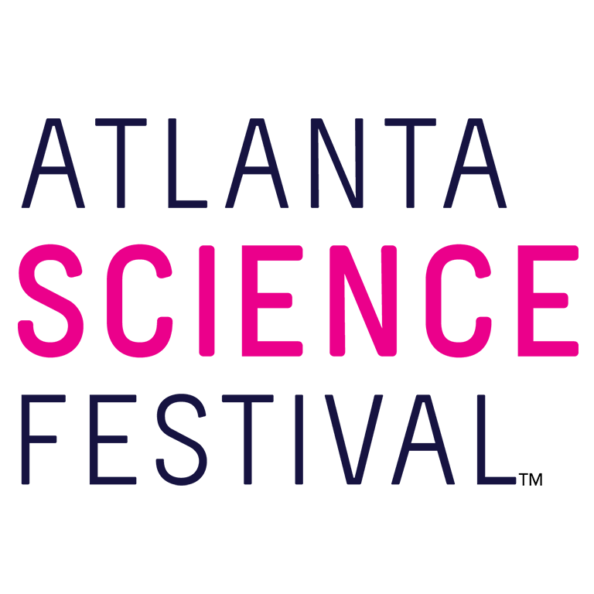
For Immediate Release:
Contact: Jon Waterhouse | Lenz, Inc.
678.770.9561
jwaterhouse@lenzmarketing.com

Atlanta Science Festival launches 2023 edition with Destination Science at Ferst Center for the Arts
On March 10, three leading scientists take audience on a journey
through the reefs of Australia to the wilds of Africa to the glaciers of the North

March 1, 2023 (Atlanta) —The Atlanta Science Festival (ASF) presented by Delta Air Lines, the city’s ultimate celebration of all things science and one of the largest of its kind in the country, launches its 2023 edition with Destination Science, an event that explores the amazing places science can take you. It takes place 7-9 p.m. March 10 at the Ferst Center for the Arts at Georgia Tech.
A trio of fascinating scientists –Dr. M Jackson, Melissa Cristina Márquez, and Rae Wynn-Grant– take the audience on a captivating, virtual journey through the reefs of Australia to the wilds of Africa to the glaciers of the North. WABE’s Molly Samuel serves as moderator.
“Destination Science celebrates the thrill and wonder of scientific experiences while kicking off the beginning of yet another amazing Festival,” says co-founder and co-executive director, Meisa Salaita. “One of our goals is to emphasize diversity and inclusion in science. For 2023, we’re grateful to spotlight these inspiring, female scientific voices.”

- Dr. M Jackson is a geographer, glaciologist, and science communicator exploring the intersections of societal transformation, glaciology, and climate change. Jackson has worked for several decades in the Arctic and Antarctic, exploring changing climates and communities.

- Melissa Cristina Márquez is a marine science education expert. Born in Puerto Rico and raised in Mexico, Melissa has worked at the forefront of marine science education and communication for more than a decade, combatting the misinformation that’s rampant in ecological fields. Additionally, she continues paving the way for Latina women like her in science.

- Rae Wynn-Grant is a wildlife ecologist who researches how human activity influences the behavior of wild animals. Her wildlife exploration and media work have taken her to six of seven continents and more than 25 countries. She uses media to increase representation of Black scientists and explorers.

“Each of these amazing women serve as perfect examples for the potential scientists of tomorrow,” Salaita explains. “They’re all authors, media personalities, trailblazers, and thought leaders who are truly making our planet a better place in the name of science.”

Tickets are $20 for adults and $12 for children. Tickets are available at ArtsGATech.unversitytickets.com.For a complete festival events list visit AtlantaScienceFestival.org/events-2023.

For additional press releases, a full schedule, updates, photos, and more, visit the Press Room at AtlantaScienceFestival.org/press-room.

Interviews are available upon request.

About the Atlanta Science Festival
The Atlanta Science Festival presented by Delta Air Lines is a two-week celebration of science and technology. Taking place March 10-25, 2023, it will feature 150 interactive and educational events. Kids and adults alike can dive into a range of topics from coding and astronomy to nature walks and science/art mashups. The Atlanta Science Festival is engineered by Science ATL and 50+ community partners, with major support from founders Emory University, Georgia Institute of Technology, and the Metro Atlanta Chamber, and sponsors Delta Air Lines, UPS, Cox, Google, NCR Foundation, and others. To learn more, visit AtlantaScienceFestival.org.

###

