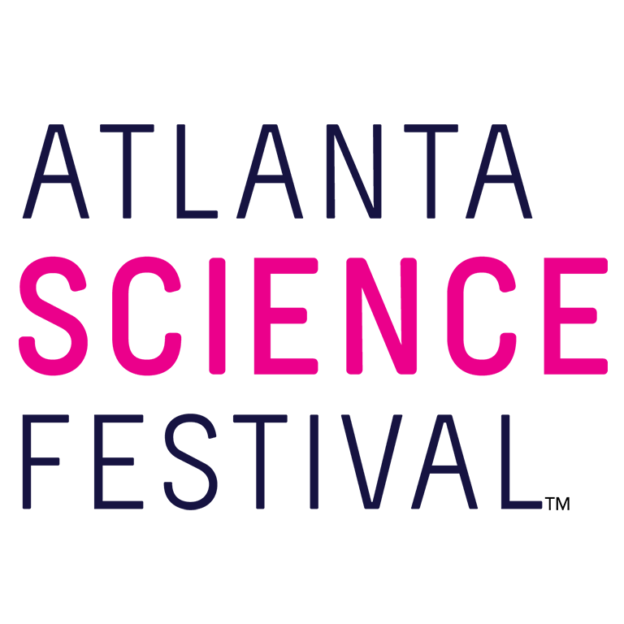
For Immediate Release:
Contact: Jon Waterhouse | Lenz, Inc.
678.770.9561
jwaterhouse@lenzmarketing.com

Atlanta Science Festival delivers interactive grand finale,
the Exploration Expo at Piedmont Park
Thousands expected to attend city’s ‘biggest science party’ March 25

March 15, 2023 (Atlanta) —The Atlanta Science Festival (ASF) presented by Delta Air Lines, the city’s ultimate celebration of all things science and one of the largest of its kind in the country, runs now through March 25 with 150 events taking place throughout metro Atlanta. ASF will once again deliver its annual, interactive grand finale, the Exploration Expo. The event materializes 10 a.m.-4 p.m. March 25 in Piedmont Park.

Thousands of curious kids and adults will descend upon Piedmont Park to experience the wonder of science with more than 90 hands-on interactive science booths and live science demos from local organizations, universities, and companies. Best of all, it’s free and takes place rain or shine.

“The Exploration Expo is always an exciting way to wrap up the Atlanta Science Festival,” says co-founder and co-executive director, Jordan Rose. “This year’s event features amazing activities like smelling the scent of outer space, 3-D printing your own bones, looking inside a jet engine, and testing your brain with laser beams. And that’s just a fraction of the fun available. There really is something for everybody.”

The Exploration Expo features seven exciting Zones where guests can dive into science experiences firsthand.

- Encounter Zone, brought to you by Emory University: Encounter electricity in motion, see what DNA looks like, check out a high-fidelity mannequin, look through microscopes, and meet remarkable women in science.
- Discover Zone, brought to you by Mercer University & Mercer Health Sciences Center: Discover how a lightbulb works, touch a snake, explore the journey of our water, and learn how to care for a sea turtle.
- Invent Zone, brought to you by Georgia Tech: Find out what’s inside a beehive, learn how muscles and bones work, see bacteria glow, and become a data point.
- Thrive Zone, brought to you by Delta Air Lines: Learn how our planet is changing, see how bugs share our brains, and dive into the geography of water.
- Curious Kids Zone, brought to you by the Atlanta Section of IEEE: Make art prints with nature, learn about the mysteries of the sea, and make your own game.
- STEAM Zone: See how science inspires art, make your own science haiku, and wrap your head around claymation.
- Power-Up Zone, brought to you by Georgia Power: Discover how electricity powers our state – and then grab a bite from the food trucks nearby.

Spicing things up at precisely 12 p.m. is the Pink Ping Pong Big Bang, when thousands of pink ping-pong balls launch into the skies. Help countdown this explosion of science in The Meadow, sponsored by Emory University and performed by Dr. Doug Mulford and the ChEmory student group.

If all of that interactive science works up an appetite, take advantage of the many food and drink vendors setting up in the park as part of the Atlanta Science Festival. Complimentary water is available at stations throughout the Expo. Seating is available at the Power-Up Zone and at tables throughout the park. Guests are welcome to bring picnic blankets, refillable water bottles, and their own snacks.

A complete exhibitor list, map, and additional event details at AtlantaScienceFestival.org/expo.

For additional press releases, a full schedule, updates, photos, and more, visit the Press Room at AtlantaScienceFestival.org/press-room.

Interviews are available upon request.

About the Atlanta Science Festival
The Atlanta Science Festival presented by Delta Air Lines is a two-week celebration of science and technology. Taking place March 10-25, 2023, it will feature 150 interactive and educational events. Kids and adults alike can dive into a range of topics from coding and astronomy to nature walks and science/art mashups. The Atlanta Science Festival is engineered by Science ATL and 50+ community partners, with major support from founders Emory University, Georgia Institute of Technology, and the Metro Atlanta Chamber, and sponsors Delta Air Lines, UPS, Cox, Google, NCR Foundation, and others. To learn more, visit AtlantaScienceFestival.org.

###

