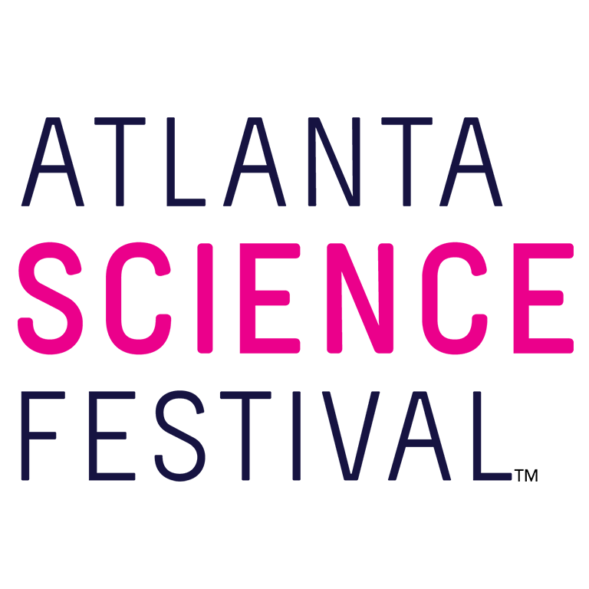
For Immediate Release:

Contact: Jon Waterhouse | Lenz, Inc.
678.770.9561
jwaterhouse@lenzmarketing.com

Atlanta Science Festival explodes with grand finale, Exploration Expo at Piedmont Park
Thousands expected to attend city’s ‘biggest science party’ March 26

March 14, 2022 (Atlanta) —The Atlanta Science Festival reaches an explosive finale with the Exploration Expo. The event materializes 10 a.m.-4 p.m. March 26 in Piedmont Park.

Festival organizers expect thousands of curious kids and adults descending upon Piedmont Park to witness the wonder of science with 75 hands-on interactive science booths and live science demos from local organizations, universities, and companies. Best of all, it’s free and takes place rain or shine.

“After a hiatus in 2020 and 2021, we’re thrilled the Exploration Expo is returning to the Atlanta Science Festival,” says co-founder and co-executive director, Jordan Rose. “Where else can you touch a human brain, write a science haiku, look inside a jet engine, and meet the city's scientists, engineers, and tech-industry experts? All of that and more help make the Exploration Expo Atlanta’s biggest science party.”

The Exploration Expo features seven exciting Zones where guests can dive into science experiences firsthand.

- Encounter Zone, brought to you by Emory University: Encounter color-changing gold nanoparticles, have a non-Newtonian dance party, test air and soil quality, learn about a raccoon vaccination campaign, and meet remarkable women in science.
- Discover Zone, brought to you by Mercer University & Mercer Health Sciences Center: Discover heart and lung sounds, make your own sunscreen, see how facial recognition software works, and check out careers in cybersecurity.
- Invent Zone, brought to you by Georgia Tech: Invent your own nanosensor, see the biology behind bees, wonder at bioluminescent organisms, control a robot with your brain, and simulate an earthquake.
- Thrive Zone, brought to you by Microsoft: Touch a human brain, test household items for radioactivity, learn how geoscientists save the world, learn how coronavirus infects humans and how vaccines protect us.
- STEAM Zone: Express your love of science in a science haiku, paint a piece of the live mural, and compose a musical masterpiece with potatoes.
- Curious Kids Zone, brought to you by the Atlanta Section of IEEE: Dig for fossils, discover biofacts, touch snakes and lizards, make slushies and bath bombs, find free science books, and see how you measure up to local birds!
- Power-Up Zone, brought to you by Georgia Power: Take a break from the science — grab a bite to eat and have a seat at this oasis of tables. Then put on some VR goggles and see what it’s like to work on power lines, how to check your home for energy efficiency, and explore drones and electric vehicles.

Spicing things up at precisely 12 p.m. is the Pink Ping Pong Big Bang, when thousands of pink ping-pong balls launch into the skies, harbingers of the day’s science celebrations.

If all of that interactive science works up an appetite, take advantage of the many food and drink vendors setting up in the park as part of the Atlanta Science Festival. Complimentary water is available at stations throughout the Expo. Seating is available at the Power-Up Zone and on tables throughout the park. Guests are welcome to bring picnic blankets and their own snacks.

For the safety of everyone, the Atlanta Science Festival’s Exploration Expo encourages attendees to be completely vaccinated, wear masks in crowded areas when social distancing is not possible, and stay at least six feet apart when possible.

A complete exhibitor list, map, and additional event details at AtlantaScienceFestival.org/expo.

For additional press releases, a full Festival schedule, updates, photos, and more, visit the Press Room at: AtlantaScienceFestival.org/press-room.

Interviews are available upon request.

About the Atlanta Science Festival
In its ninth year, the Atlanta Science Festival is a two-week celebration of science and technology. Taking place March 12-26, 2022, it will feature more than 100 interactive in-person and virtual events. Kids and adults alike can dive into a range of topics from coding and astronomy to nature walks and science/art mashups. The Atlanta Science Festival is engineered by Science ATL and 50+ community partners, with major support from founders Emory University, Georgia Institute of Technology, and the Metro Atlanta Chamber, and sponsors Delta, UPS, International Paper, NCR Foundation, and others. To learn more, visit AtlantaScienceFestival.org.

###

