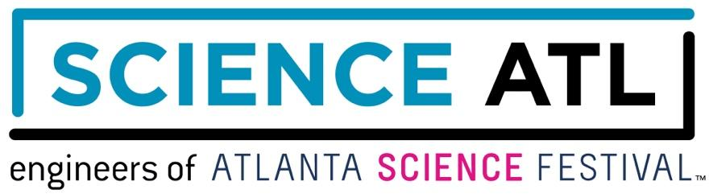
MEET OUR CO-EXECUTIVE DIRECTORS

Meisa Salaita

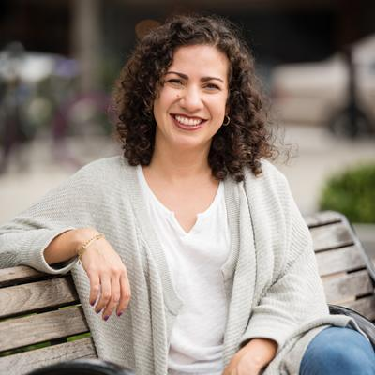

Meisa Salaita has made it her mission to help others see and appreciate the beauty of science by making it a part of everyday cultural experiences. Through her work founding and directing Science ATL, she spends her days convincing everyone else to fall in love with science as well. To that end, Meisa also writes, has produced radio stories, and hosted TV shows - all in the name of science. In addition to her work with Science ATL, Meisa is one of the Atlanta-based producers for The Story Collider, a science storytelling podcast. Meisa has a Ph.D. in chemistry from Northwestern and has been named by the Atlanta Business Chronicle as one of 20 Women Who Mean Business in Atlanta and as one of Atlanta Magazine’s Women Making a Mark. Meisa has two kids, dances hip-hop as much as she can, and wants to be reading young adult literature all the time.

Jordan Rose

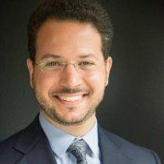

Jordan Rose is a creative, lifelong learner with a passion for promoting science literacy and empowering youth to lead change. With Science ATL, Jordan brings together schools, companies, and community organizations to improve equitable access to Atlanta’s myriad opportunities to learn and love science. Previously, Jordan led science education initiatives via the Georgia BioEd Institute and the Emory College Center for Science Education, supporting K-12 teachers and students and facilitating university-community partnerships. He is a 2021-22 Education Policy Fellow with the Georgia Partnership for Excellence in Education and serves on advisory boards for Georgia Tech’s GIFT program, and the Georgia BioEd Institute. Jordan has a B.S. in neuroscience and a Master’s in Public Health from Emory University. He lives in Tucker and enjoys playing tennis, riding bikes with his family, rooting for Atlanta United, and jamming on the ukulele.
###

