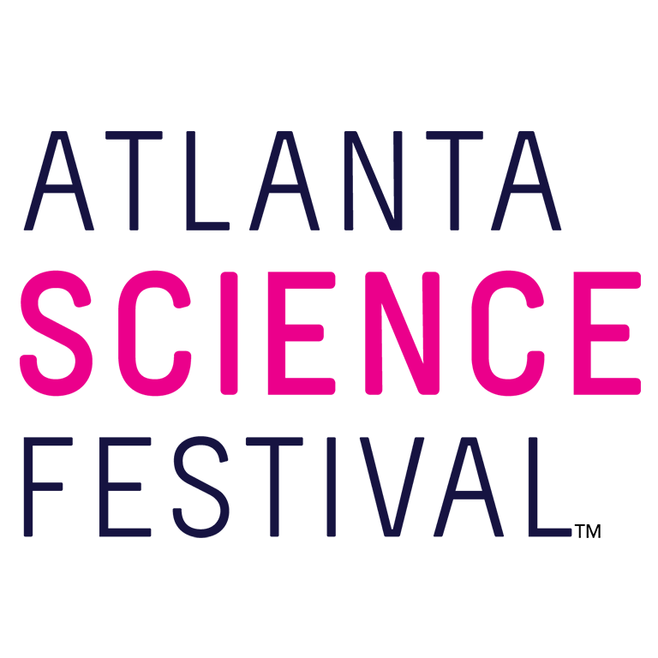
For Immediate Release:

Contact: Jon Waterhouse | Lenz, Inc.
404.373.2021
jwaterhouse@lenzmarketing.com

Atlanta Science Festival offers activities for all ages
More than 100 events take place March 9-23 at locations throughout Metro Atlanta

March 4, 2019 (Atlanta) — The Atlanta Science Festival, a two-week celebration presented by Delta Air Lines, strikes a chord with science lovers of all ages. Taking place March 9-23, the Festival offers more than 100 events at locations throughout Metro Atlanta. Among them you’ll find specific programming designed especially for kids, families, teens, and adults.

“Science touches us all,” said Meisa Salaita, executive co-director of Atlanta Science Festival. “So we take a something-for-everybody approach to our programming, and inject a blast of fun into an array of engaging and educational events.”

The Atlanta Science Festival powers itself with STEAM —an acronym for science, technology, engineering, arts, and mathematics — and offers events in each of those categories. The following events, ranging in cost from free to a nominal fee, are just an example of the dozens of activities available. For a full schedule, visit the Atlanta Science Festival Website.

For Everyone

Exploration Expo
11 a.m.-4 p.m. March 23. Free. Piedmont Park, 1071 Piedmont Ave., Atlanta.
The Atlanta Science Festival culminates in Atlanta’s biggest family science event for all ages and interests. Touch a human brain! Pet a python! Squeeze into a mock MRI scanner! Play robot soccer! Make your own gummy worms! Listen to your joints! Look up your own nasal passages! Excavate a fossil! Spin the Wheel of Bugs! Touch a jet engine! Make a pollen map of Atlanta!
With more than 100 hands-on, interactive science booths from local organizations, universities, and companies, the Exploration Expo puts the spotlight on Atlanta science. This is a rain or shine event.

For Kids and Families

Mathapalooza!
1 p.m. March 9. Free. Ebster Recreation Center, 105 Electric Ave., Decatur.
Explore the wonder of mathematics, art, performance, and magic! Spend the afternoon exploring puzzles and games, and engaging with mathematics through music, magic tricks, movement, and visual art. You will be amazed at the beauty of mathematics and how it shows up everywhere in our lives.

Family Zoo Yoga: “Panda”monium Style
8:30 a.m. March 10. $10. Zoo Atlanta, 800 Cherokee Ave. S.E., Atlanta.
Forget Downward Dog! We're doing Downward Panda! Get down with Zoo Atlanta’s pandas in a new way through the Family Yoga Program. During this hour-long event for families, you'll enjoy yoga featuring panda-inspired poses. After yoga, we'll explore more about Pandas, their habitat, and how we all can work to conserve this unique species. After the class, we encourage you to stick around and visit the Zoo. All non-Zoo members will be provided with a 20% off coupon to use towards Zoo admission.

“Galapagos George, the Little Tortoise That Could: A Puppetry Adventure”
10 and 11:30 a.m. March 22. $14.63 (this includes ASF discount.) Center for Puppetry Arts, 1404 Spring St. N.W., Atlanta.
Join the Center for Puppetry Arts and Barefoot Puppet Theatre as they introduce you to “Galapagos George, the Little Tortoise That Could!” Your amazing Atlanta Science Festival experience will include a puppet show, a Create-A-Puppet WorkshopTM, the Worlds of Puppetry Museum with specialized learning stations, AND a special appearance by some reptilian friends visiting from the Amphibian Foundation! Have a blast learning about animals, ecology, and the STEAM of puppetry. Note that this show will be running at the Center for Puppetry Arts from March 19-31, so if you aren't able to come to any of our special ASF shows, you can still be part of the magic on another day! Use code "ASF19" for 25% off any showing that takes place during the Festival (March 19, 20, 21, 22) and catch the related STEAM activities!

For Teens

Complete the Circuit: Meet a Woman Scientist!
2 p.m. March 9. $5 per family. General Assembly at Ponce City Market, 675 Ponce De Leon Ave. N.E., 2nd floor, Atlanta.
Young girls need female role models if we want to close the gender gap in science and engineering. This event is a chance for middle-school girls to meet face-to-face with real women in science, ask questions about their careers, and imagine themselves as scientists, too. Together, we’ll build a circuit and play games to encourage discussion. Parents will learn about how to nurture their daughter’s love of science and help them succeed. And there will be ice cream!

Eating Bugs: A Graphic Novelist’s Perspective
7 p.m. March 11. $5 per family. Little Shop of Stories, 133A E. Court Square, Decatur.
Blue Delliquanti spent years researching and diving into the world of entomophagy (the practice of eating insects) to write her graphic novel Meal. Come hear about her culinary adventures and research process as she tells us all about how Meal came to be. We'll have scientist and entomophagist Chelsea Thomas there to tell us more about why eating insects should be the wave of the future. And maybe you'll get to try one of these delightful treats!

WABE Presents: Ask a Scientist
3 p.m. March 16. Free with advance registration. Discovery Center at Georgia World Congress Center, 275 Northside Drive N.W., Atlanta.
Why is wombat poop cubed? How did bacteria make Earth habitable for humans? What kind of weather happens in space? WABE, Atlanta’s NPR station, presents scientists from different disciplines as they demystify their fields of study, and offer us a chance to Ask a Scientist. Join WABE’s science reporter, Molly Samuel, and science enthusiasts of all ages, for an educational, entertaining, and exciting afternoon. Free parking in the nearby Gold Deck (127 Northside Drive N.W., Atlanta) will be available to all event guests.

For Adults

Guthman Musical Instrument Competition
7 p.m. March 9. Free. Ferst Center for the Arts at Georgia Tech, 349 Ferst Drive N.W., Atlanta.
A music, engineering, and tech mashup, the Georgia Tech Margaret Guthman Musical Instrument Competition is an annual event aimed at identifying the world's next generation of musical instruments and unveiling the best new ideas in musicality, design, engineering, and impact. The Guardian called the competition “The Pulitzer of the New Instrument World,” and The New York Times described the “special, otherworldly sound that you can feel permeating your soul,” which became the hallmark of the competition. Fast Company explained how Guthman's “Futuristic Instruments will change how we make music,” and Atlanta Magazine suggests that “at the Guthman Competition, innovative instruments just might predict the future of music.”

Neuro-Engineering: Blurring the Lines Between Mind and Machine
7:30 p.m. March 11. $5. Monday Night Garage, 933 Lee St. S.W., Atlanta
Controlling computers and robots with thoughts? Modifying brain activity to treat disorders such as Alzheimer's Disease and depression without medication? New neurotechnologies can sound like fantasy, but what is science fact and what is science fiction? As this technology blurs the lines between mind and machine, does it change our definition of what it means to be human? Local technology and ethics researchers leading the neuro-engineering revolution will address these questions in an engaging interactive discussion, including live audience demonstrations of neural interfaces. Presenters will be faculty from Emory and Georgia Tech leading neuroengineering or neuroethics research efforts: Dr. Chethan Pandarinath, Dr. Karen Rommelfanger, Dr. Christopher Rozell, and Dr. Annabelle Singer.

Science Riot
7:30 p.m. March 14. $15. Highland Inn Ballroom, 644 N. Highland Ave., Atlanta.
Take some scientists, teach them the basics of comedy writing, and put them onstage for a live audience performance. Real Science. Real Experts. Real Funny. Limited free parking is available in the adjacent lot and in nearby streets. Paid parking is available in the garage across the street.

For additional press releases, a full schedule, updates, photos, and more, visit the Press Room at: AtlantaScienceFestival.org/press-room.

Interviews are available upon request.

About the Atlanta Science Festival
In its sixth year, the Atlanta Science Festival, presented by Delta Air Lines, is a two-week celebration of science and technology with more than 100 engaging events held across Metro Atlanta, March 9-23. These include hands-on activities, facility tours, presentations, and performances at a variety of locations. The grand finale of the Festival is an all-day interactive Exploration Expo at Piedmont Park on March 23. Founded by Emory University, Georgia Institute of Technology and the Metro Atlanta Chamber, the organization is dedicated to bringing people together through the wonder of science with its spring festival and year-round Science ATL programming. To learn more, visit AtlantaScienceFestival.org and ScienceATL.org.

###

