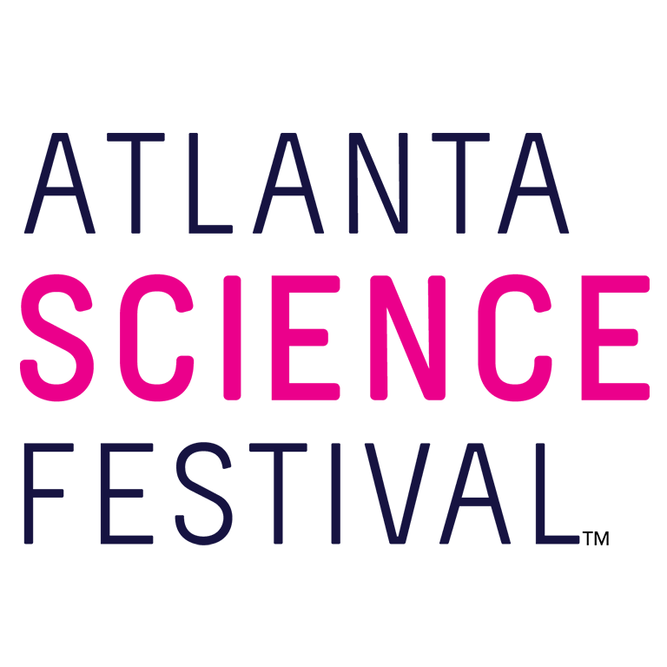
For Immediate Release:

Contact: Jon Waterhouse | Lenz, Inc.
404.373.2021
jwaterhouse@lenzmarketing.com

Atlanta Science Festival explodes with grand finale, Exploration Expo at Piedmont Park
More than 25,000 expected for city’s ‘biggest science party’ March 23

March 18, 2019 (Atlanta) —The Atlanta Science Festival reaches an explosive finale with its annual Exploration Expo. The event materializes 11 a.m.-4 p.m. March 23 in Piedmont Park.

Festival organizers expect more than 25,000 curious kids and adults descending upon Piedmont Park to witness the wonder of science with more than 100 hands-on interactive science booths, live science demos, and shows from local organizations, universities, and companies. Best of all, it’s free and takes place rain or shine.

“The Exploration Expo is the biggest science party Atlanta has ever seen,” says co-founder and co-executive director, Jordan Rose. “I love watching the kids’ eyes light up when they touch a human brain, or a newt, or a newt’s brain! Honoring the science that’s happening in Atlanta is truly a cause for celebration, and we are proud to showcase local innovators, innovations ,and the pathways to STEM careers at our Expo.”

The Exploration Expo features seven exciting Zones where guests can dive into science experiences firsthand. You can see a complete exhibitor list and Exploration Expo map here.

- Encounter Zone, brought to you by Emory University: Encounter herbs and microbes, measure Atlanta’s pollen count, and create Minecraft code.
- Discover Zone, brought to you by Mercer University & Mercer Health Sciences Center: Discover the microscopic world, battle bots, and chemical reactions.
- Invent Zone, brought to you by Georgia Tech: Invent your own music by coding, touch a brain, touch a heart, peep at physics, drive an underwater robot!
- Thrive Zone, brought to you by Georgia State University: See how native plants and pollinators thrive, fold origami, and become a ham radio operator.
- Curious Kids Zone, brought to you by the Atlanta Section of IEEE: Turn your little ones into future scientists and engineers with STEM and STEAM activities specifically for ages 3 and older.
- STEAM Zone: Express your love of science with a science haiku, paint a piece of the live mural, and see evolution in action!
- Power-Up Zone, brought to you by Georgia Power: Take a break, grab a bite to eat and have a seat at this oasis of tables. Then, put your new energy to good use as you pedal a human-powered generator, form a human circuit, and explore robots and drones.

Spicing things up at precisely 12 p.m. is the Pink Ping Pong Big Bang, when thousands of pink ping-pong balls launch into the skies, harbingers of the day’s science celebrations.
If all of that interactive science works up an appetite, take advantage of the many food and drink vendors setting up in the park as part of Atlanta Science Festival. Vendors include Jim ’N Nick’s Bar-B-Q, Spice the Americas, Mixed Up, South of Philly, Repicci’s, Island Chef Café, Bhojanic, Cookie Truck, and King of Pops.

For additional press releases, a full Festival schedule, updates, photos, and more, visit the Press Room at: AtlantaScienceFestival.org/press-room.

Interviews are available upon request.

About the Atlanta Science Festival
In its sixth year, the Atlanta Science Festival, presented by Delta Air Lines, is a two-week celebration of science and technology with more than 100 engaging events held across Metro Atlanta, March 9-23. These include hands-on activities, facility tours, presentations, and performances at a variety of locations. The grand finale of the Festival is an all-day interactive Exploration Expo at Piedmont Park on March 23. Founded by Emory University, Georgia Institute of Technology and the Metro Atlanta Chamber, the organization is dedicated to bringing people together through the wonder of science with its spring festival and year-round Science ATL programming. To learn more, visit AtlantaScienceFestival.org and ScienceATL.org.

###

