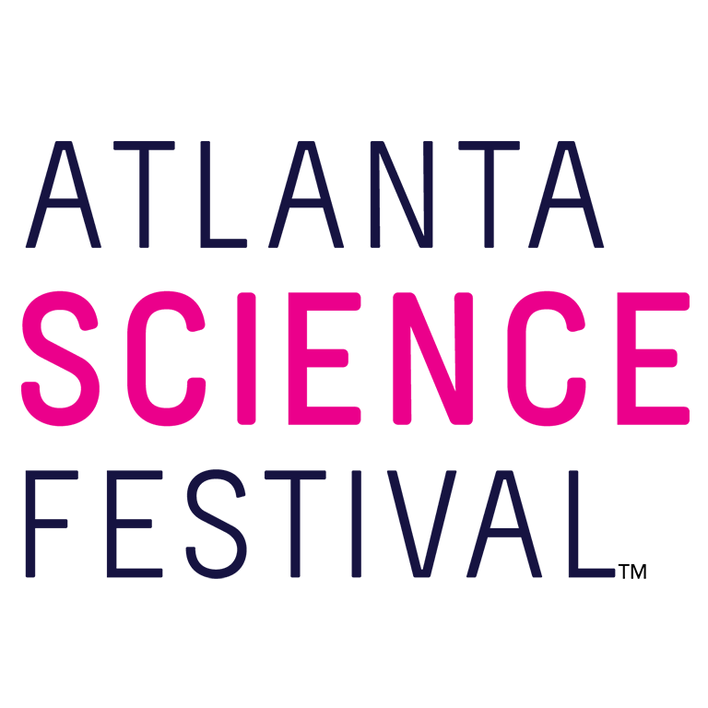
For Immediate Release:

Contact: Jon Waterhouse | Lenz, Inc.
404.373.2021
jwaterhouse@lenzmarketing.com

Atlanta Science Festival unveils 2019 programming, NPR guests
Atlanta’s preeminent science celebration continues sponsorship with Delta Air Lines

January 24, 2019 (Atlanta) — Atlanta Science Festival (ASF), the city’s premier celebration of all things science, returns with explosive events and excitement for 2019. Today Atlanta Science Festival representatives unveiled the schedule taking place March 9-23, 2019. Delta Air Lines continues as presenting sponsor.

“We’re passionate about sharing the beauty of science, technology, engineering, and mathematics with the whole Atlanta community,” says Jordan Rose, executive co-director of Atlanta Science Festival. “And there’s no better place than Atlanta, which continues to be a global leader in scientific innovation.”

The Atlanta Science Festival begins with its signature launch event, and this time science lovers of all ages will exclaim a collective, “Wow!” It will feature a live performance of the “Wow in the World Pop Up Party,” based on the popular NPR science-themed podcast “Wow in the World.” Host Mindy Thomas serves up games and skits with live musical accompaniment by the Pop Ups, creators of the “Wow in the World” theme song. (11 a.m. March 9. $15; $10 ages 12 and younger. Glenn Memorial Church, 1660 N. Decatur Road, Atlanta.)

After the Wow in the World Pop Up Party launch event, the following two weeks will find guests exploring science and technology at more than 100 engaging events, ranging in cost from free to a nominal fee. These include hands-on activities, facility tours, presentations, and performances at a variety of locations throughout Metro Atlanta. Expect drones and nano-tattoos, panda yoga and comedy, archeological digs, nature walks, ice cream tastings, art, trivia, curling, superheroes, beavers, newts, and bees. And that’s just the tip of the telescope.

The Atlanta Science Festival culminates in the Exploration Expo, Atlanta’s biggest family science event. Thousands of curious kids and adults descend upon Piedmont Park to experience the wonder of science with 100 hands-on interactive science booths, live science demos, and shows from local organizations, universities, and companies. Attendees can experience everything from touching a human brain to driving an undersea robot. (11 a.m.-4 p.m. March 23. Free. Piedmont Park, at the intersection of Charles Allen Drive and 10th Street, Atlanta.)

“We’re thrilled to watch the Festival grow each year, and 2019 is no exception,” says Meisa Salaita, executive co-director of Atlanta Science Festival. “Our sixth installment is more exciting than ever, and we’re grateful for Delta Air Lines to help us continue soaring to new heights.”

For additional press releases, a full schedule, updates, photos, and more, visit the Press Room at: AtlantaScienceFestival.org/press-room.

Interviews are available upon request.

About the Atlanta Science Festival
In its sixth year, the Atlanta Science Festival, presented by Delta Air Lines, is a two-week celebration of science and technology with more than 100 engaging events held across Metro Atlanta. These include hands-on activities, facility tours, presentations, and performances at a variety of locations. The grand finale of the Festival is an all-day interactive Exploration Expo at Piedmont Park on March 23. The Atlanta Science Festival’s mission is to celebrate the inherent integration of STEAM (science, technology, engineering, arts, and mathematics) in our lives today, to share the impact that STEAM has on our community, and to inspire us all to wonder about our future. The Festival, taking place March 9-23, is produced by a collaboration of science, cultural, and educational institutions, founded by Emory University, Georgia Institute of Technology and the Metro Atlanta Chamber. To learn more, visit AtlantaScienceFestival.org.

###

