MEET OUR CO-DIRECTORS

Meisa Salaita

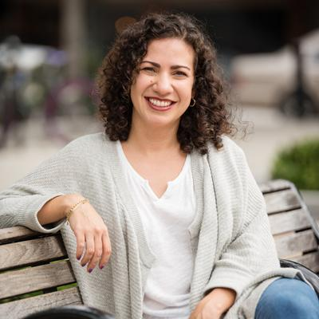

Meisa Salaita has made it her mission to help others see and appreciate the beauty of science by making it a part of everyday cultural experiences. Through her work founding and directing the Atlanta Science Festival, she spends her days convincing everyone else to fall in love with science as well. To that end, Meisa also writes, has produced radio stories, and hosted TV shows - all in the name of science. In addition to her work with the Festival, Meisa is one of the Atlanta-based producers for The Story Collider, a science storytelling podcast. Meisa has a Ph.D. in chemistry from Northwestern, and was recently named by the Atlanta Business Chronicle as one of 20 Women Who Mean Business in Atlanta.

Jordan Rose

Jordan Rose is a creative, lifelong learner with a passion for promoting science literacy and building community partnerships. As co-founder and co-director of Atlanta Science Festival, Rose is helping to bring together schools, universities, companies, and museums to celebrate Atlanta’s STEAM ecosystem and highlight opportunities for the public to learn and love science. Previously, Rose has led science education initiatives via the Georgia BioEd Institute and the Emory College Center for Science Education, supporting K-12 teachers and students and facilitating university-community partnerships. Rose has a B.S. in neuroscience and a Master’s in Public Health from Emory University. He serves on the boards of Georgia Tech’s GIFT program, the Georgia BioEd Institute, and the Technology Association of Georgia Education Collaborative.

