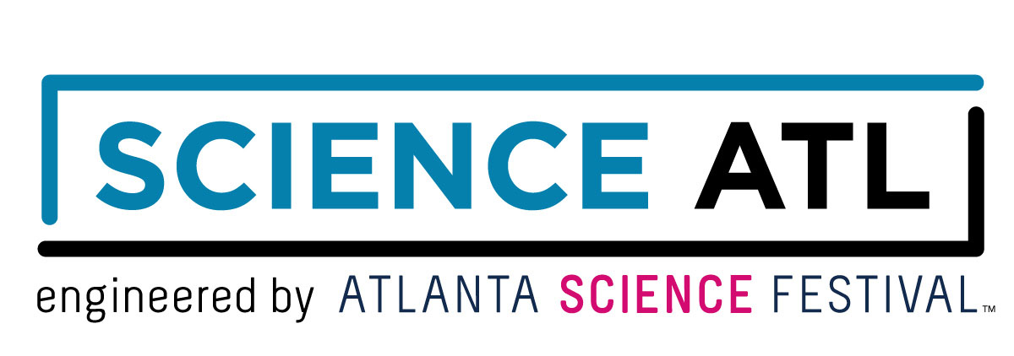
For Immediate Release:

Contact: Jon Waterhouse | Lenz, Inc.
404.373.2021
jwaterhouse@lenzmarketing.com

Science ATL delivers year-round special events,
educational opportunities to metro Atlanta
This extension of Atlanta Science Festival now accepting corporate sponsorships

August 23, 2018 (Atlanta) — The creators of Atlanta Science Festival –the immensely popular, annual celebration of science and technology– proudly announce the formation of Science ATL. Science ATL offers all of the wonder, discovery, and excitement of the Atlanta Science Festival year-round. This includes hosting science-themed events and educational opportunities for all ages. Science ATL is now accepting corporate sponsorships to help fully realize its mission.

“Science is a through-line of our daily existence,” said Meisa Salaita, co-founder of Science ATL and co-director of Atlanta Science Festival. “Atlanta is truly a science city – home to tremendous learning opportunities and a variety of STEM careers. Honoring this culture of innovation, we are expanding the spirit of Atlanta Science Festival throughout the entire year.”

Science ATL launches with programming taking place this fall and more to come.

- The Science Scene Calendar: Want to keep tabs on scientific fun taking place throughout the city? Visit this online calendar of metro Atlanta happenings, connecting science enthusiasts, both young and old. Available now.
- Georgia Chief Science Officers – This program develops a group of middle and high school students as STEM leaders in their schools and communities, giving them the opportunity to meet with legislators, school board members, STEM industry mentors, and businesses. Available now.
- Science ATL Communication Training: This fellowship trains scientists on how to better communicate with a range of public audiences, and gives them the opportunity to develop and execute at least two public engagement activities. Available now.
- Science ATL Passport – Students use these passports to document science in their everyday lives, creating a living record of how they engage with STEM outside the classroom. Coming soon.
- Science ATL Events: Beginning summer 2019, Science ATL will curate its own quarterly events similar to those found at Atlanta Science Festival. Think scientific superstars, live demonstrations, hands-on engagement, and more. Coming summer 2019.

“Atlanta Science Festival is working with fantastic partners to enrich the STEM community in Atlanta,” said Salaita. “For Science ATL to succeed in branding Atlanta as a science city, we need to rally even more likeminded supporters of science, technology, engineering, and math.”

Corporations can join forces alongside current sponsors such as Delta Air Lines, Metro Atlanta Chamber, Emory University, Georgia Institute of Technology, and more.

Current sponsor testimonials:

“Science ATL and the Atlanta Science Festival emphasize the fact Atlanta remains a hub for scientific advancement and innovation. There couldn’t be a better backdrop to showcase science-infused businesses and inspire the scientists of tomorrow.”
-Hala Moddelmog, president and CEO of Metro Atlanta Chamber

“For years the Atlanta Science Festival has provided creative, hands-on activities to introduce young people to science applications in our daily lives. With the launch of Science ATL, they can have those experiences year-round throughout our community, helping to inspire the next generation to explore STEM fields.”
-Georgia Tech President G. P. “Bud” Peterson

“As an academic community committed to creativity and discovery, we at Emory are extremely proud of our involvement with Atlanta Science Festival. The launch of Science ATL allows us to celebrate the importance of scientific inquiry year-round—it’s a great day for the entire metro Atlanta area and well beyond.”
-Claire E. Sterk, president of Emory University

“Georgia Power remains committed to engaging more students in science, technology, engineering, and math to generate tomorrow’s STEM workforce. Our partnership with Science ATL and the Atlanta Science Festival helps further that mission in a major way right here in our own backyard.”
- Anne Kaiser, VP Community & Economic Development, Georgia Power

Sponsorship inquiries can be directed to: 770-322-4992, info@atlantasciencefestival.org.

Interviews are available upon request.

About Atlanta Science Festival Inc.
Atlanta Science Festival Inc. is a 501(c)(3) nonprofit organization dedicated to bringing people together through the wonder science. Founded in 2014 by Emory University, Georgia Tech, and Metro Atlanta Chamber, the organization produces the annual two-week Atlanta Science Festival, presented by Delta Air Lines, which has brought science programming to more than 200,000 people in the metro Atlanta region. The two-week Festival celebrates local science and technology every March, featuring more than 100 events throughout metro Atlanta and reaching 50,000 children and adults annually. Festival events feature hands-on activities, tours, tastings, and performances with 100 partner organizations, plus the Exploration Expo, Atlanta's biggest interactive family science event. Atlanta Science Festival Inc. is now extending this excitement year-round through a series of programming and partnership-building initiatives called Science ATL. The new Science ATL initiatives will increase public interest in and appreciation of science in Atlanta by creating and promoting easy access points to science, technology, engineering and math throughout the year. In 2018, Science ATL will launch an online public science events calendar, the Chief Science Officers leadership program for middle and high school students, a science activity passport, and a science communication fellowship. In the future, Science ATL will produce additional public science events and learning opportunities throughout the year.

###

