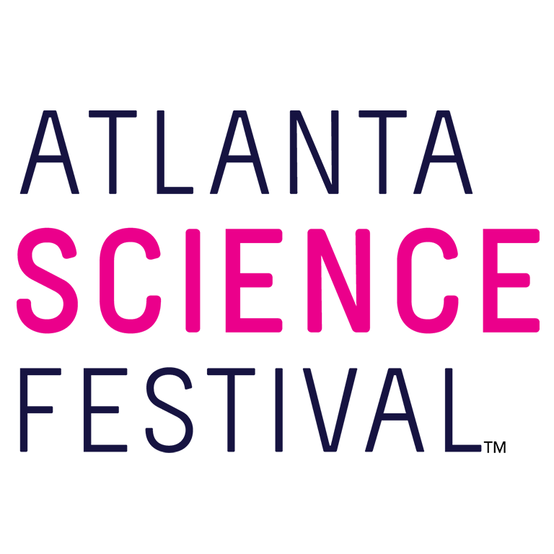
For Immediate Release:

Contact: Jon Waterhouse | Lenz, Inc.
404.373.2021
jwaterhouse@lenzmarketing.com

Atlanta Science Festival offers activities for all ages
More than 100 events take place March 9-24 at locations throughout Metro Atlanta

March 5, 2018 (Atlanta) — The Atlanta Science Festival, a two-week celebration presented by Delta Air Lines, strikes a chord with science lovers of all ages. Taking place March 9-24, the Festival offers more than 100 events at locations throughout Metro Atlanta. Among them you’ll find specific programming designed especially for kids, families, teens, and adults.

“Science touches us all,” said Meisa Salaita, executive co-director of Atlanta Science Festival. “So we take a something-for-everybody approach to our programming, and inject a blast of fun into an array of engaging and educational events.”

The Atlanta Science Festival powers itself with STEAM —an acronym for science, technology, engineering, arts, and mathematics — and offers events in each of those categories. The following events, ranging in cost from free to a nominal fee, are just an example of the dozens of activities available. For a full schedule, visit the Atlanta Science Festival Website.

For Everyone

Rise Up, Robots!
7 p.m. March 9. $15. Ferst Center for the Arts, Georgia Institute of Technology, 349 Ferst Drive, Atlanta.
Humans should prepare to bow down to the 'bots. “Rise Up, Robots!” puts the spotlight on a droid comedian, a robot musician, a bionic arm, and more. Guests can arrive at 6 p.m. to experience an interactive Robot Petting Zoo. Check online for tickets.

Exploration Expo
11 a.m.-4 p.m. March 24. Free. Piedmont Park, 1071 Piedmont Ave., Atlanta.
The Atlanta Science Festival culminates in Atlanta’s biggest family science event. Thousands of curious kids and adults descend upon Piedmont Park to witness the wonder of science with 100 hands-on interactive science booths, live science demos, and shows from local organizations, universities, and companies. Attendees can experience everything from touching a human brain to driving an undersea robot. This is a rain or shine event.

For Kids and Families

Puppets + STEM = Science in Motion
9 a.m.-1 p.m. March 12. $8.50. Center for Puppetry Arts, 1404 Spring St. N.W., Atlanta
Join us at the Center for Puppetry Arts as we celebrate the science of puppets! We invite you to take part in a super fun, hands-on exploration of the magical place where puppetry and STEM (Science, Technology, Engineering, and Math) collide. You'll see how the scientific method has inspired some of the coolest puppetry projects EVER, how technology is used to create our incredible Center for Puppetry Arts puppet shows, how engineering is harnessed to design and build puppets all over the world, and how math skills are applied in our Create-A-Puppet Workshops. You'll tour our Museum, build a puppet, and enjoy interactive STEM stations and live puppetry demonstrations. A fun-filled day -- guaranteed to educate, entertain, and inspire -- awaits!

Discovery Day: Discovery Stations
9:30 a.m.-2:30 p.m. March 17. Free. Petit Science Center at GSU, 100 Piedmont Ave. S.E., Atlanta.
Explore four floors of hands-on science demonstrations from GSU departments and student groups. Learn about the science of ice-cream (and make some yourself), the wonders of 3-D printing, help build a robot, and get a picture of yourself as a mad scientist! Identify various dinosaur footprints throughout the exhibits and exchange your scientific discoveries for a prize! Be sure to check out the other parts of Discovery Day (Eureka Labs and Fusion Gallery) as well. Check online for parking information.

Kids Day on the Farm
Noon-5 p.m. March 18. $3. Truly Living Well, 324 Lawton St. S.W., Atlanta.
Come visit a real-life science lab—an organic farm! Families will have the opportunity to explore the science of a real farm right inside the city. Come prepared to romp on this beautiful farm, get your hands a little dirty, and learn about food and farming. We will have plenty of kid-friendly activities. Dress for the weather, and bring your own water and snacks. Free parking is available on site.

For Teens

TECHNOSELF with Deantoni Parks
8-10 p.m. March 16. $7-$10. Red Light Café, 553-1 Amsterdam Ave., Atlanta.
Critically acclaimed drummer Deantoni Parks will present a special performance and conversation that explores the balancing of technology and self. Parks will explore how musicians augment their natural talents with technology, harnessing its powers to fuel their own vision.

Crime Scene Investigation Squad
10 a.m.-1 p.m. March 17. Free with advance registration. Georgia Gwinnett College School of Science & Technology, 1000 University Center Lane, Building H2, Lawrenceville.
Do you like to watch crime solving TV shows like “NCIS,” “Bones,” or “CSI”? Want to get in on the action and solve a 'crime' yourself? Then join the Crime Scene Investigation Squad! First, you'll visit a mock crime scene to collect some evidence. Next, you'll take it to the CSIS forensics lab to analyze your samples and connect the potential perpetrator to the crime. Finally, you'll present your 'expert' evidence to the investigators so an arrest can be made. This event is designed for ages over 12. Free parking available on site.

G4C Game Jam
11 a.m.-3 p.m. March 17. Free with advance registration. Historic Academy of Medicine, 875 W. Peachtree St. N.W., Atlanta.
The Games for Change (G4C) Student Challenge is a national game design program that invites you to create digital games about issues impacting your community. You will get to work with educators and experts to create games around the theme of 'Connected Cities.' Through the Game Jam, you will learn how Atlanta is being transformed through design, innovation and technology. Then, you will get to apply your new knowledge to game design through a series of game making stations/activities. This event is open to all students grades 6-12. Paid street parking available.

For Adults

The Golden Record
3 and 6 p.m. March 11. $12-$18. The Space, 4620-A S. Atlanta Road S.E., Atlanta.
The Hereafter Artist Collective, Flight of Swallows, and Georgia Tech faculty are collaborating to bring performance art to the Atlanta Science Festival. Forty years ago, Carl Sagan arranged to send The Golden Record into space as a part of the Voyager Mission. The Golden Record, two phonograph records full of sounds and images, serves as a time capsule for future life forms to one day look back upon our existence. Under the direction of the Hereafter Artist Collective, this performance piece incorporates aerial arts, modern dance, and live music to explore the themes of this “time capsule” and how humanity may appear to those lifeforms. Will humanity be but a fairytale and The Golden Record just a beautiful moment when we reached to the stars looking to “join a community of galactic civilizations”? Free on-site parking is available.

From Orchard to Barrel: The Science of Sour Beers
1-3 p.m. March 18. $15. Monday Night Garage, 933 Lee St. S.W., Atlanta.
Totally unique to the craft beer scene nationally and locally, Monday Night has been leading the way within the craft beer movement. At The Garage, brewmasters worked with Shades of Green Permaculture to design an organic orchard that will produce wild yeast that will be passively harvested to make beers on-site that reflect the unique flavors of plants and fruits in the outdoor space. Learn about the science behind it all! Check online for tickets.

Science Improv
7:30-9:30 p.m. March 21. $5-$10. Whole World Improv Theater, 1216 Spring St., Atlanta.
Improv comedy with a science twist! Scientists, improvisation artists, and the audience combine to show the lighter side of science and life in the lab through short improv games and sketches. Check online for tickets.

For additional press releases, a full schedule, updates, photos, and more, visit the Press Room at: AtlantaScienceFestival.org/press-room.

Interviews are available upon request.

About the Atlanta Science Festival
In its fifth year, the Atlanta Science Festival, presented by Delta Air Lines, is a two-week celebration of science and technology with more than 100 engaging events held across Metro Atlanta. These include hands-on activities, facility tours, presentations, and performances at a variety of locations. The grand finale of the Festival is an all-day interactive Exploration Expo at Piedmont Park on March 24. The Atlanta Science Festival’s mission is to celebrate the inherent integration of STEAM (science, technology, engineering, arts, and mathematics) in our lives today, to share the impact that STEAM has on our community, and to inspire us all to wonder about our future. The Festival, taking place March 9-24, is produced by a collaboration of science, cultural, and educational institutions, founded by Emory University, Georgia Institute of Technology and the Metro Atlanta Chamber. To learn more, visit AtlantaScienceFestival.org.

###

