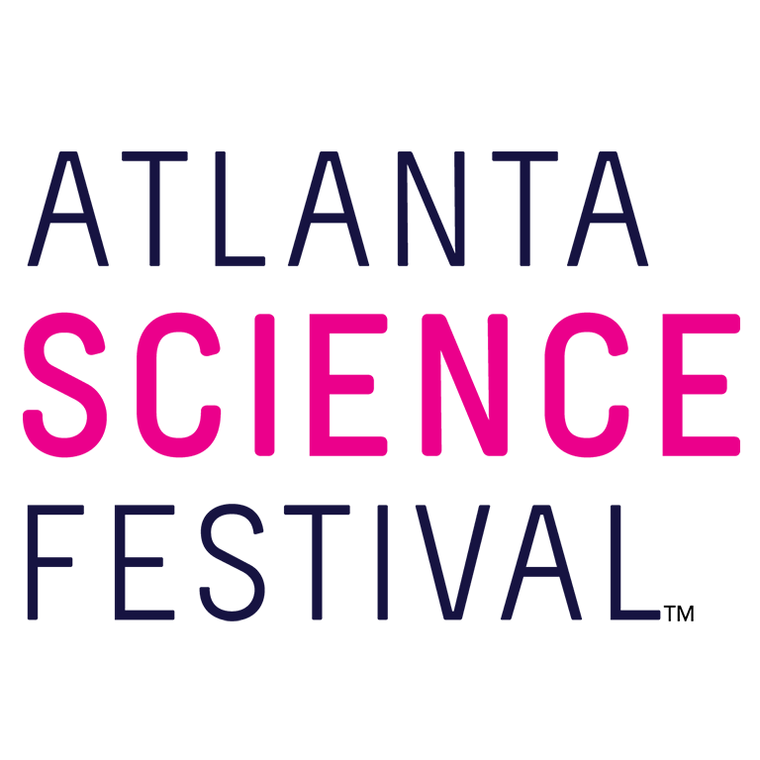
For Immediate Release:

Contact: Jon Waterhouse | Lenz, Inc.
404.373.2021
jwaterhouse@lenzmarketing.com

Atlanta Science Festival launches with explosive programming
Two-week science celebration promises more than 100 events March 9-24

February 12, 2018 (Atlanta) — Cue the rocket boosters. In less than a month, the fifth annual Atlanta Science Festival (ASF) launches with more than 100 events spread across Metro Atlanta March 9-24. Delta Air Lines serves as the Festival’s presenting sponsor.

The action begins March 9 with the Atlanta Science Festival’s signature launch event. This time humans should prepare to bow down to the 'bots. “Rise Up, Robots!” puts the spotlight on a droid comedian, a robot musician, a bionic arm, and more. Guests can arrive at 6 p.m. to experience an interactive Robot Petting Zoo. (7 p.m. March 9. $15. Ferst Center for the Arts, Georgia Institute of Technology, 349 Ferst Drive, Atlanta.)

Proud to be hosting the launch event at Georgia Tech, Paul Goldbart, honorary Festival chair said, “As Dean of the College of Sciences at Georgia Tech, I lovingly champion the Atlanta Science Festival and all it has to offer.”

The offerings continue for two weeks as guests of all ages explore science and technology with more than 100 engaging events, ranging in cost from free to a nominal fee. These include hands-on activities, facility tours, presentations, and performances at a variety of locations. Expect drones and robots, comics and comedy, farms and orchards, nature walks, ice cream tastings, art, trivia, curling, superheroes, beavers, newts, and bees. And that’s just the tip of the telescope. The full schedule of events can be found here: atlantasciencefestival.org/events.

The Atlanta Science Festival culminates in the Exploration Expo, Atlanta’s biggest family science event. Thousands of curious kids and adults descend upon Piedmont Park to witness the wonder of science with 100 hands-on interactive science booths, live science demos, and shows from local organizations, universities, and companies. Attendees can experience everything from touching a human brain to driving an undersea robot. (11 a.m.-4 p.m. March 24. Free. Piedmont Park, 1071 Piedmont Ave., Atlanta. This is a rain or shine event.)

“In the language of physics, I’m excited to observe the acceleration of the Atlanta Science Festival and the momentum of the enthusiasm found in participants and organizers alike,” Goldbart added.

For additional press releases, a full schedule, updates, photos, and more, visit the Press Room at: AtlantaScienceFestival.org/press-room.

Interviews are available upon request.

About the Atlanta Science Festival
In its fifth year, the Atlanta Science Festival, presented by Delta Air Lines, is a two-week celebration of science and technology with more than 100 engaging events held across Metro Atlanta. These include hands-on activities, facility tours, presentations, and performances at a variety of locations. The grand finale of the Festival is an all-day interactive Exploration Expo at Piedmont Park on March 24. The Atlanta Science Festival’s mission is to celebrate the inherent integration of STEAM (science, technology, engineering, arts, and mathematics) in our lives today, to share the impact that STEAM has on our community, and to inspire us all to wonder about our future. The Festival, taking place March 9-24, is produced by a collaboration of science, cultural, and educational institutions, founded by Emory University, Georgia Institute of Technology and the Metro Atlanta Chamber. To learn more, visit AtlantaScienceFestival.org.

###

