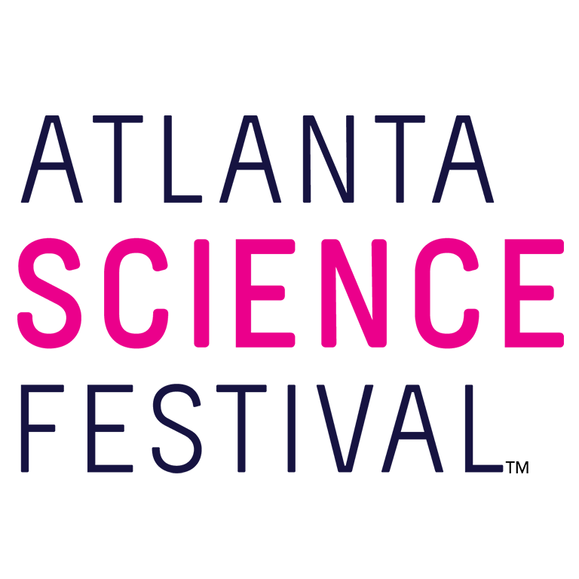
For Immediate Release:

Contact: Jon Waterhouse | Lenz, Inc.
404.373.2021
jwaterhouse@lenzmarketing.com

Atlanta Science Festival unveils 2018 programming, robotic guests
Atlanta’s preeminent science celebration announces sponsorship with Delta Air Lines

January 25, 2018 (Atlanta) — Place your seat backs and tray tables in their upright positions. The Atlanta Science Festival (ASF) soars to new heights in 2018 with its presenting sponsor, Delta Air Lines. Today Atlanta Science Festival representatives unveiled the schedule for this annual scientific celebration, taking place March 9-24, 2018.

“Sharing the magic of science, technology, engineering, and mathematics with the community is more important than ever,” said Jordan Rose, executive co-director of Atlanta Science Festival. “Our goal is to do this in fun, compelling, and accessible ways. With Atlanta being a global leader in scientific innovation, our city is the perfect backdrop.”

The Atlanta Science Festival begins with its signature launch event at Georgia Institute of Technology. This time humans should prepare to bow down to the ’bots. “Rise Up, Robots!” puts the spotlight on a droid comedian, a robot musician, bionic and robotic prosthetics, and a squad of interactive robots. (7 p.m. March 9. $15 plus fees. Ferst Center for the Arts, 349 Ferst Drive, Atlanta.)

The featured “Rise Up, Robots!” speakers include:

Heather Knight
Assistant Professor of Robotics at Oregon State University, founder of Marilyn Monrobots Lab
Perhaps best known for her popular TED Talk appearance, Knight brings Data, the world’s first robotic jokester, to the “Rise Up, Robots!” stage. Knight will explain how she injects charisma into her creation, and give a live demonstration of Data’s interactive quips. Among her accolades, Knight has graced the cover of Wired UK magazine and was named to the 2011 Forbes List for 30 under 30 in Science. Her current research involves human-robot interaction, non-verbal machine communications, and non-anthropomorphic social robots.

Gil Weinberg
Professor and Founding Director of Georgia Tech Center for Music Technology
Yep, robots rock. Weinberg proves the point in the literal sense with Shimon, a marimba playing robotic musician. Shimon, seen on NBC’s “Today” show, uses machine learning for jazz improvisation, and Weinberg will show the “Rise Up, Robots!” audience how it’s done. Weinberg’s other projects include a prosthetic robotic arm, which restores and enhances human drumming abilities for amputees. He’s presented his work worldwide at venues such as The Kennedy Center and the Cooper-Hewitt, Smithsonian Design Museum, and for the TED-Ed online lesson series. Weinberg’s research focuses on developing artificial creativity and musical expression for robots and augmented humans. Professor Weinberg’s appearance is supported in part by the Atlanta Jewish Music Festival.

Stewart Coulter
Engineering Manager at DEKA Research & Development
A prosthetic, bionic arm with a hand that can pinch, grip, and conform to the objects it holds? Sounds like science fiction, but it’s science fact. Just ask Coulter. The LUKE arm can do all of that and more. Coulter served as the project manager for the LUKE arm, which stands for Life Under Kinetic Evolution. At “Rise Up, Robots!,” Coulter will give a demonstration and provide live evidence of how it changed someone’s life.

After the “Rise Up, Robots!” launch event, the following two weeks will find guests of all ages exploring science and technology at more than 100 engaging events, ranging in cost from free to a nominal fee. These include hands-on activities, facility tours, presentations, and performances at a variety of locations throughout Metro Atlanta. Expect drones and robots, comics and comedy, farms and orchards, nature walks, ice cream tastings, art, trivia, curling, superheroes, beavers, newts, and bees. And that’s just the tip of the telescope.

The Atlanta Science Festival culminates in the Exploration Expo, Atlanta’s biggest family science event. Thousands of curious kids and adults descend upon Piedmont Park to experience the wonder of science with 100 hands-on interactive science booths, live science demos, and shows from local organizations, universities, and companies. Attendees can experience everything from touching a human brain to driving an undersea robot. (11 a.m.-4 p.m. March 24. Free. Piedmont Park, at the intersection of Charles Allen Drive and 10th Street, Atlanta.)

“We’re excited to take the 2018 Festival into new and exciting territory, and blend it with our time-honored events and signature spirit,” said Meisa Salaita, executive co-director of Atlanta Science Festival. “Joining forces with Delta Air Lines gives us the ability to do it all.”

For additional press releases, a full schedule, updates, photos, and more, visit the Press Room at: AtlantaScienceFestival.org/press-room.

Interviews are available upon request.

About the Atlanta Science Festival
In its fifth year, the Atlanta Science Festival, presented by Delta Air Lines, is a two-week celebration of science and technology with more than engaging 100 events held across Metro Atlanta. These include hands-on activities, facility tours, presentations, and performances at a variety of locations. The grand finale of the Festival is an all-day interactive Exploration Expo at Piedmont Park on March 24. The Atlanta Science Festival’s mission is to celebrate the inherent integration of STEAM (science, technology, engineering, arts, and mathematics) in our lives today, to share the impact that STEAM has on our community, and to inspire us all to wonder about our future. The Festival, taking place March 9-24, is produced by a collaboration of science, cultural, and educational institutions, founded by Emory University, Georgia Institute of Technology and the Metro Atlanta Chamber. To learn more, visit AtlantaScienceFestival.org.

###

